ALL INDIA INSTITUTE OF SPEECH AND HEARING
अखिल भारतीय वाक एवं श्रवण संस्थान
DEPARTMENT OF SPECIAL EDUCATION
विशेष शिक्षा विभाग
JANUARY MONTHLY REPORT 2017
- ACADEMIC ACTIVITIES
- Short-term Training Programs: NIL
- Faculty report
- Dr. M. Pushpavathi – HOD in Special Education

- Attended purchase related meeting on 21.2.17
- Attended ISO training awareness program on 22.2.17
- Conducted meeting with faculty and staff on 24.2.17

- Dr. G. Malar, Reader in Special Education

- Co-compiler for M.S.Ed.(HI) Dissertation Based Articles 2015-16
- CBCS Coordinator for B.Ed.Spl.Ed. (HI)
- Mentor for B.Ed.Spl.Ed. (HI)
- Depute staff to Department for Tele-rehabilitation for Persons with Communication Disorders
  - Preparation of adapted lessons for clients & academic screening tools (Maths & EVS – grades I to VIII)
- Member of Expert Committee of Product Development Cell
- Member-Secretary of Learning Disabilities Clinic
  - Postings in Wednesday afternoons. Assistance to Chairperson in preparing minutes of meetings. Carried out educational screening/assessment of 6 learners during the month.
- I/C of SEA-U, Department of Special Education
- I/C of Research & Data Base Unit, Department of Special Education
- I/C of EduTechLab, Department of Special Education
- Member-Secretary of Team for Delivering Services for School-Aged Children [including CSS, IEP, NFE & Mainstream School Adoption], Department of Special Education
- Supervisor for 10 preschool groups – Aambal II, Sebu, Maavu, Baale, Sampige I & II, Sugandharaja I & II, Mallige II, and Sevanthi I with 57 children

Name of the Faculty |  | Dr. Alok Kumar | Dr. G. Malar | Dr. Prithi Venkatesh | Dr. P. Vijetha
Clinics
No. of cases evaluated at SEA-U |  | 11 | Screening: 17  Assessment: NIL | Early Development Checklist-2 ongoing  SEAU cases-4 | 04
No. of cases supervised individually |  | NIL | 20 children in 5 groups thru’ 5 sessions of classroom observations | NIL | NIL
No. of groups supervised |  | 08 | 10 | 8 | 32
No. of meeting with parents |  | 05 | 08 | 8 | 09
Educational Guidance |  | 01 | Clients: 10  Sessions: 10 | NIL | 02 (5 sessions)
Academic
Classes taken
B.Ed.  Spl.Edn(HI) | Theory | 21 classes | 26 Sessions | 14 classes (10 taken, 4 OOD) | 29 classes
B.Ed.  Spl.Edn(HI) | Practical | 15 hours | 68 hours | 2 hours | 19 hours
DECSE(HI) | Theory |  |  | 15 classes | 14 classes
DECSE(HI) | Practical |  |  | 48 hours | 20 hours
Any other |  | - Verification of obsolete furniture for Clean India Movement in Institute.  - Chairperson of Special event committee for Open day |  |  | - On 8th February 2017, attended APS interview in the forenoon.  - On 27th February, submitted C1 marks of B.Ed trainees.  - Coordinating the practice teaching sessions of DECSE(HI) trainees in Preschool and paper II practicum.  - Supervised the practice teaching sessions in special schools of B.Ed. II year trainees.  - Correction of B.Ed. Lesson plans in social sciences.  - Attended Peer evaluation of Dept. of Audiology on 15th March 2017.  - On 28th February 2017,Served as a Resource person and delivered a talk on “Different ways of using official language –Hindi in scientific workshops” in the fourth Hindi workshop
Research
Paper published |  | 02 (Journal of NCED in volume 7 & volume 8) |  | Chapter in Book ICT in Education ‘Information (ISBN Number-978-93-85957-08-6) and Communication Technology for Children with Communication disorders’ | Vijetha P. (2016). Impact of Early intervention by a Multidisciplinary team on development of a child with hearing impairment: A case study. Journal of National Convention of Educators of the Deaf, 8(1), 41-49.
Paper in press/ in progress |  | 03 |  | One Chapter in a book ‘ICT for Children with Special Needs’ | Submitted paper titled “Impact of Early intervention by a Multidisciplinary team on development of a child with hearing impairment: A case study ” to be reviewed and published in JNCED 2017
Paper presentation |  | As served as a Key note Speaker in Annual NCED Conference and topic was “Impact of accessible India and digital India on C.W.H.I”on 23/02/17  Presented Paper in NCED Conference and topic was “Effectiveness of multimedia as teaching learning material to primary school children with hearing impairment” on 21/02/17 |  | Knowledge and Attitude of teachers towards Government Initiatives for Children with Hearing Impairment-Paper presented at NCED Conference , Jodhpur | Submitted paper titled “Impact of Adapted social studies lessons on learning in children with hearing impairment” to be presented in the National Seminar on Research in Social Sciences Education in Indian schools to be held from 15th to 17th March 2017 at New Delhi.
ARF Project |  |  | Sanctioned 1
Thesis Evaluation/Project Review
Any other
Meeting held |  |  | - 2 monthly meetings with I & II B.Ed. students  - 2 meetings regarding ARF project  - 1 meeting for Open Day Committee for CWSN |  | - On 1st February 2017,Attended meeting with members for Open day Exhibition committee.  - Corrected NIE students project work.
Meeting attended |  |  | 1 with HOD – Special Education
AV preparation
Brochures
Orientation Programme
Workshop |  |  |  |  | - On 22nd Feb 2017 Attended ISO 9001: 2015 Awareness training program presented by Mr. Rajesh.  - Coordinated in submitting the E-affiliation of UOM of the dept. staff.
Roles & Responsibilities
Co-ordination |  | Infant & Toddler Unit | - CBCS Coordinator for I & II B.Ed. Spl.Ed. (HI)  - Mentor for I & II B.Ed.Spl.Ed. (HI)  - Compilation of M.S.Ed. Student Dissertation-based Articles 2014-15  - Intra-Department  - SEA-U  - EduTechLab  Research & Database Unit |  | ISO  Circulated MOPs to be updated  Service for School aged children  - As a part of Mainstream school adoption program, finalized PPT presentation for Orientation program II and submitted to HOD.  Checked for the numbering of the TLMs
Member secretary |  | Preschool | - LD Clinic (in DCS)  - Services for School-Aged Children (in Department of Special Education) | Served as member secretary in catering committee for Open Day Celebration on 3rd February 2017. In this connection attended two rounds of meeting with chairperson at director’s Chamber  Serving as a member Secretary in SEAU | Service for Infant and Toddlers
Member in |  | SEA-U | - TCPD  - Product Development Cell  - Evaluator for UoM UG courses in special educator  - Preschool Supervision | SEA-U | SEA –U  Prepared school readiness reports of four clients and submitted
Mentor |  | M.Sc. -1st Year -Audiology
- Orientation Programs:

Name/Topic of the Program | Coordinator | Objectives | Targeted Audience | Number of Participants | Date
Orientation on Preschool Training for Children with Communication Disorders | Mr.Gururaj D. | Developing awareness on preschools education for Children With Special Needs | ASHA workers | 47 | 06.02.2017
Orientation on Preschool Training for Children with Communication Disorders | Mr.Gururaj D. | Developing awareness on preschools education for Children With Special Needs | Shanthala, Chaithanya Spl Edu School, Sagara, Shimoga | 01 | 07.02.2017

- Seminars/Conferences/Workshops:
Name/Topic of the Program | Coordinator | Organized by Dept./Section/Unit | Targeted Audience | Number of Participants | Date
Half day Orientation programme on the topic ‘Special Olympics and Paralympics’ | Ms. Vijayalakshmi S  Ms. Asha Suresh E G  Mr. Subramanya K R  Mr. Gururaj D  Resource Person:  Sri.Vasanthkumar Shetty  Area Director,  SOB Karnataka  Mangalore | Department of Special Education | Parents & Special Children | 350 | 22.02.2017
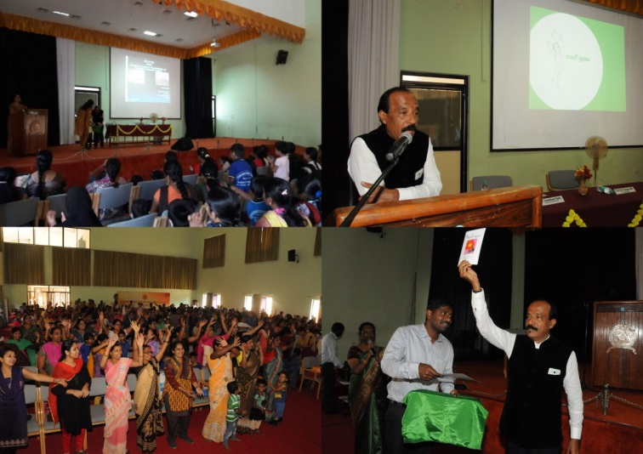
Photo:

- In- house training Programs: NIL
- Staff Enrichment Programs (SEP’s) : NIL
- Empowering Educators in Education (E³): NIL
- Guest Lectures :
- Invited Talks: 05

- Dr. Alok Kumar Uphadhyay served as a Key note speaker: Title “Impact of Digital India and Accessible India for Children with hearing impairment” organized by NCED Conference, Jodhpur on 23.02.2017.
- Dr. Prithi Venkatesh served as a Resource person and delivered lecture on "Assessment Instruments for Identifying Difficulties in Mathematics and Mastery Learning-Concepts and Strategies" in the PAC programme organized by RIE, Mysuru on 14th & 15th February 2017.
- Dr. Malar G served as a Resource person and delivered lecture on "Curriculum Adaptation for Students with Learning Disability(LD) " in the PAC programme organized by RIE, Mysuru on 18.02.2017.
- Mr. Suresh C B served as Resource person and delivered lecture on “ Role of Special educators in promoting Inclusive education of CWSN using Technology” in the Science day Celebration organized by Mar Thoma College, Chungathara, Kerala on 27.02.2017.
- Dr. Palnaty Vijetha gave a talk on the topic “Different ways of using official language Hindi in scientific workshops” in the fourth workshop organized by OLI cell, AIISH, Mysuru on 28th February 2017.

- Development of Materials to Support Learning
- Service in Academic bodies of other Organizations- NIL
- Membership in Professional Organizations/Associations - NIL
- Participation in Committees/Taskforce and Panels setup by other organizations/agencies-
- Any Other (Please Specify).

- RESEARCH ACTIVITIES
- Research Projects
- Completed Research Projects: NIL
- New Research Projects: NIL
- On-going Research Project : 01
- Title of ARF - Development and Evaluation of Indigenous curriculum oriented computer based tutor for concept learning in preschool children with special needs.
- Principal Investigator – Ms. P.V.Ramanakumari
- Co-Investigators – Dr. Ajish K Abraham and Ms. P.V.Manjula
- Research Assistant – Mr. Anil Abbur R.
- Date of Starting – 18th January 2017
- Progress –Story board writing of My Family, My Body and Things we use. On 28th February spoke and gave a part of script for sample animated computer based tutor.

- Doctoral and Post-Doctoral Programs: NIL
- Degree Awarded:
- Thesis awarded:
- Thesis Submitted:
- Under Progress:
- Research Papers presented at National/International Conferences/Seminars: 07
The following papers have been presented at National Convention of Educators of the Deaf (NCED) India, Rajasthan at Chapter & Ajay Leela Special Teacher Training College, Jodhpur, 21-23 February 2017.

SL No. | Date | Resource person | Research paper title name
1 | 22.02.2017 | Dr. Alok Kumar Upadhyay | Effectiveness of multimedia as a teaching learning material to primary school children with hearing impairment
2 | 21.02.2017 | Dr. Prithi Venkatesh | Knowledge and Attitude of teachers towards Government Initiatives for Children with Hearing Impairment
3 | 22.02.2017 | Ms. P.V. Ramanakumari | Journey of a Early Intervened and Implanted Child Towards Inclusion : A Case Study
4 | 23.02.2017 | Ms. Manjula P.V | Caregivers’ Knowledge and Use of Available Apps, Tools and Software in Training their Wards with Hearing Impairment.
5 | 22.02.2017 | Mr.Rajkumar | Inclusive Education for Children with Hearing Impairment: Role of Early Childhood Educational Program
6 | 23.02.2017 | Mr. Vijayalakshmi. S | A Study on impact of digital awareness in teaching – learning process
7 | 22.02.2017 | Dr. Kadambari | Early identification to intervention- identifying predictors to successful inclusion of children with hearing impairment

- Research Papers Published(in APA format):
    - Papers published in Conference/Seminar Proceedings
    - Research Papers in press- NIL
    - Research Papers published in Journals: 03

G. Malar, Alok kr. Upadhyay & Alam M. (2016). Efficacy of conventional Analytical Reading Technique Versus Sight word Technique in Promoting Reading Skills in Preschool Children with Hearing Impairment. Journal of National Convention of Educators of the Deaf, Vol VII, No.1
Alok kr. Upadhyay (2017). Comparison Environment Characteristics between Inclusive and Non Inclusive setups with reference to Deaf and Hard of Hearing Children. Journal of National Convention of Educators of the Deaf, Vol VIII, No.1
Vijetha P. (2016). Impact of Early intervention by a Multidisciplinary team on development of a child with hearing impairment: A case study. Journal of National Convention of Educators of the Deaf, 8(1), 41-49.
    - No. of in-house journal articles:
    - Books published.

- Book chapters published(in APA format)
Chapter in Book ICT in Education ‘Information (ISBN Number-978-93-85957-08-6) and Communication Technology for Children with Communication disorders’

- Books in press :
- Books/Manuals/Seminar Proceedings edited
- Journal Editorship
- Scholarly Reviewing Activities
- Reviewer for Scholarly Journals
- M.S.Ed (HI) Dissertations Guided by Faculty
- Clinical Support Services to Patients and Family
- Details of Certificates Issued:

Details of Bonafide Certificates Issued:

Sl.No. | Nature of Special Needs in Clients | No. of Certificates Issued | Purpose
1 | DSL,MR | For applying pension, scholarship, and admission for mainstream integration school. | 04
2 | DSL, HL | Admission for mainstream integration school | 03
- Clinical Electronic Services: NIL
V) CENTRAL FACILITIES
      - Library and Information Services
      - Public Information Activities
- Major Events of the month of December with a brief account:
The department staff organized drawing competition to all preschool children on 8th Feburary 2017 to create awareness about swachh bharat on account of the visit of Shri Sanjeev Kumar, Additional Secretary, Ministry of Health and Family Welfare, Govt. of India
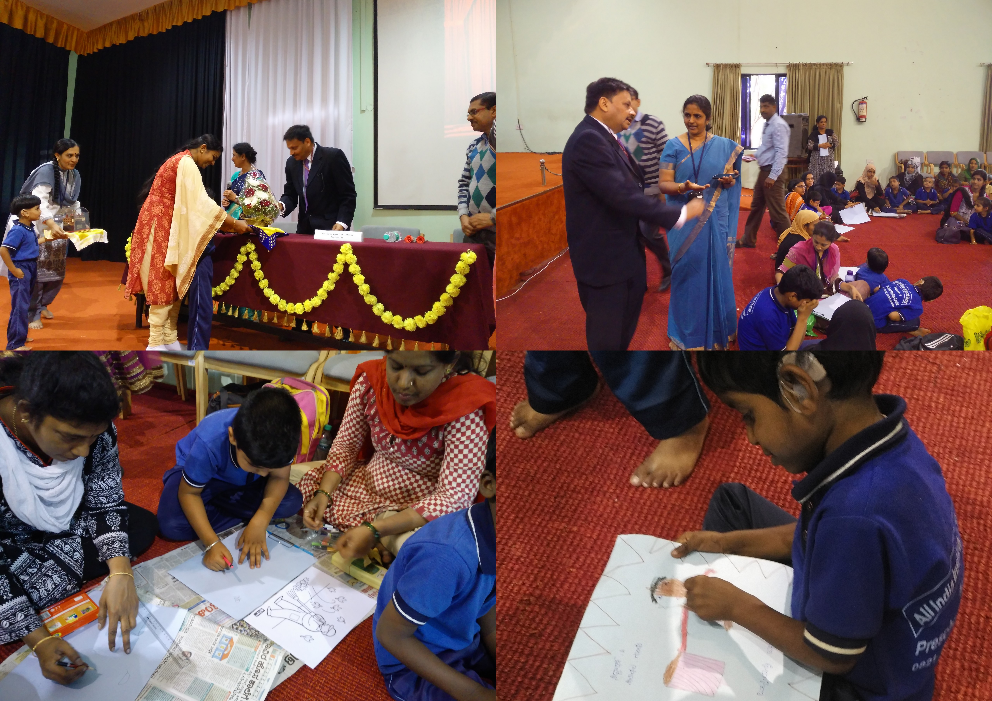
Participants:- 200 Preschool children with various communication disorders

- Press Releases and Media Coverage
- Institute Publications -
- Material Development
Sl.  No. | Nature of Teaching-Learning Materials | Skill | Number
1. | Flash cards | For all skill areas | 174 sets
2. | Work Cards | For all skill areas | 126 sets
3. | Charts | For all skill areas | 17
4. | PPT | For all skill areas | 29
5. | Models | For all skill areas | 1
6. | Sentence strips | For all skill areas | 117 sets
7. | Others | For all skill areas | 0
- AWARDS AND HONORS RECEIVED BY FACULTY AND STAFF
- 4 Awards for paper presentation in NCED 2017, Jodhpur

  - Smt. Annapurna Memorial award for best research paper in special education Award won by
Alok kr. Upadhyay, Shaik Gulab (2017). Paper titled “Effectiveness of multimedia as a teaching learning material to primary school children with hearing impairment”.

  - Dr. Prakash Gathoo award for best research paper in Special Education Award won by
V. Prithi, N. Kadambari (2017). Paper titled “Knowledge and Attitude of teachers towards Government Initiatives for Children with Hearing Impairment”.

  - M.C. Sen award for Best Research paper in Special Education Award won by
S. Vijayalakshmi, H. P. Sumana (2017). Paper titled “A Study on impact of digital awareness in teaching – learning process”.

  - Smt. Annapurna Memorial award for best paper on Technological Development for PWD’s. Award won by
P. V. Manjula, P. V. Ramanakumari (2017). Paper Titled “Caregivers’ Knowledge and Use of Available Apps, Tools and Software in Training their Wards with Hearing Impairment”.
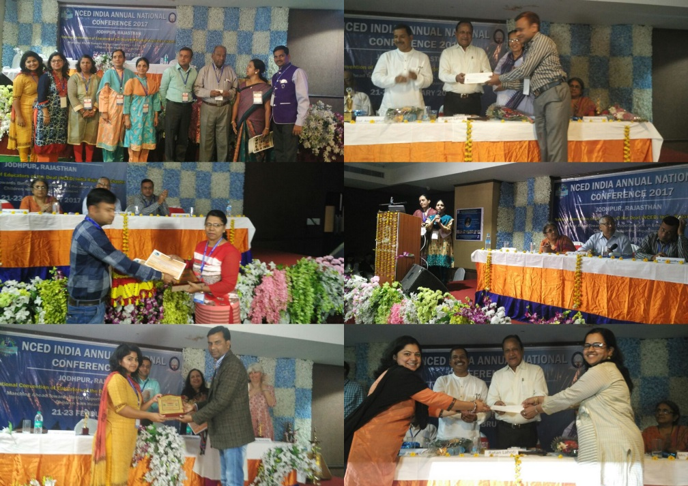

- EXTRA CURRICULAR ACTIVITIES
- Others:
IX. EMINENT VISITORS: NIL
X. ANY OTHER
- Official Language Implementation:
- One word a day in Hindi.

- Special Educational Services Offered through Teacher Trainees Outside Campus:

S. No. | Nature of Activity | Services Provided | Details of Beneficiaries
1. | Educational Assessment | --- | ---
2. | Practice-Teaching in Mainstream Schools/ Institutions | - Classroom Instruction in Gangothri Public School  - Classroom Instruction in GHPS, Kudure Mala  - Remedial Instruction in Gangothri Public School | - 114  - 12  - 25
3. | Practice-Teaching in Special Schools/ Institutions | - Classroom Instruction in JSS Polytechnic for Differently-Abled  - Puttveeramma Residential School for Girls with Hearing Impairment | - 200  - 17
4. | School Screening for Communication Disorders & Referrals | --- | ---
5. | Community Survey for Disabilities & Referrals | --- | ---
6. | Mobilisation of CBR related activities | - Assistance in AIISH Open Day on 03.02.2017 | 756 CWSN & 100 caregivers
7. | Orientation of Mainstream B.Ed. Trainees | --- | ---
8. | Any Others (Specify) | --- | ---

- SPECIAL EDUCATIONAL SERVICES
- Pre-School Training and Special Education
  - Monthly Statistics Special Educational Services

S. No. | Nature of Services (I/C)
- Special Educational Assessment Services (Dr. G. Malar)
 |  | Nature of Special Need  Language |  | ASD / PDD NOS | Hearing Loss | Intellectual Disability |  | Learning Disability | Motor Problems |  | Multiple Disabilities | Others | No. of Clients | No. of Sessions | Total No. of Sessions
1. | Screening & Referral | Kannada |  | - | 8 | 3 |  | - | - |  | 5 | 4 | 20 | 20 | 41
1. | Screening & Referral | Malayalam |  | 1 | - | 5 |  | - | - |  | 3 | 2 | 11 | 11 | 41
1. | Screening & Referral | Hindi |  | - | 3 | 1 |  | - | - |  | - | 1 | 5 | 5 | 41
1. | Screening & Referral | Urdu |  | - | 1 | - |  | - | - |  | - | - | 1 | 1 | 41
1. | Screening & Referral | English |  | 1 | - | - |  | - | - |  | - | 1 | 2 | 2 | 41
1. | Screening & Referral | Telugu |  | - | - | - |  | - | - |  | 2 | - | 2 | 2 | 41
1. | Screening & Referral | Tamil |  | - | - | - |  | - | - |  | - | - | - | - | 41
1. | Screening & Referral | Any Other |  | - | - | - |  | - | - |  | - | - | - | - | 41
1. | Screening & Referral | Total No. of Clients |  | 2 | 12 | 9 |  | - | - |  | 10 | 8 | 41 | 41 | 41
2. | Assessment & Report | Kannada |  | - | 2 | - |  | - | - |  | - | - | 2 | 4 | 5
2. | Assessment & Report | Malayalam |  | - | - | - |  | - | - |  | - | - | - | - | 5
2. | Assessment & Report | Hindi |  | - | - | - |  | - | - |  | - | - | - | - | 5
2. | Assessment & Report | Urdu |  | - | - | - |  | - | - |  | - | - | - | - | 5
2. | Assessment & Report | English |  | 1 | - | - |  | - | - |  | - | - | 1 | 1 | 5
2. | Assessment & Report | Telugu |  | - | - | - |  | - | - |  | - | - | - | - | 5
2. | Assessment & Report | Tamil |  | - | - | - |  | - | - |  | - | - | - | - | 5
2. | Assessment & Report | Any Other |  | - | - | - |  | - | - |  | - | - | - | - | 5
2. | Assessment & Report | Total No. of Clients |  | 1 | 2 | - |  | - | - |  | - | - | 3 | 5 | 5
2. | Places from which seen: (1)Karnataka: 28 (2)Kerala: 9 (3)AP: 1 (4)TN: 1 (5)Other Parts of India: 1 – UP & WB(6)Any other: Nil
2. | Age groups seen:(1)Birth to 2.5yrs: 9 (2)2.5⁺ to 6 yrs: 22 (3)6yrs⁺ to 16 years: 10 (4)16yrs⁺: Nil
2. | Total No. of Referrals: (1)Educational Assessment: 3 (2)Educational Guidance: Nil (3)PIP: 9 (4)PPEP/ PBC/ GECS: 23 (5)CSS/IEP/NFE/DET: 6 (6) Any Other Services at AIISH: Nil (7) Any Other Services Outside AIISH: Nil
2. | No. of Reports Issued: (1) Early Development Skills: Nil (2) School Readiness: Nil (3) Curriculum-Based Assessment: Nil (4) Post-School Preparedness: Nil
3. | On-going Assessment (as part of service delivery) |  | Figure:
 | Details of Assessments |  | No. of Children |  |  |  | No. of Assessment Sessions |  |  | No. of Reports
 | As part of Parent-Infant Programme: |  | Nil |  |  |  | Nil |  |  | Nil
 | As part of Preschool Parent-Empowerment Programme: |  | Nil |  |  |  | Nil |  |  | Nil
 | As part of Preschool Training Programme &  As part of Preschool Bridge Course Programme: |  | 197 |  |  |  | 80 |  |  | Nil
 | As part of CSS/ IEP/NFE: |  | 24 |  |  |  | 29 |  |  | Nil

Preschool Training (Ms. Prithi Venkatesh):Preparatory programme for schooling providing training in self-help, cognitive, language and (pre) academic skills, Preschool Bridge course
Language & Disability | No. of Groups | No. of Children
 |  | MALE | FEMALE
Kannada ASD & ID &MD | 14 | 44 | 18
Kannada HI | 10 | 41 | 28
Malayalam HI | 1 | 3 | 2
Malayalam ASD & ID & MD | 10 | 23 | 15
Hindi HL | 1 | 7 | 0
Hindi MD & ID & ASD | 2 | 6 | 2
English ID, ASD | 2 | 5 | 3
TOTAL Number of children |  | 129 | 68
TOTAL No. Groups | 40 | 197
Sessions | 3040 (Group wise) 19 days

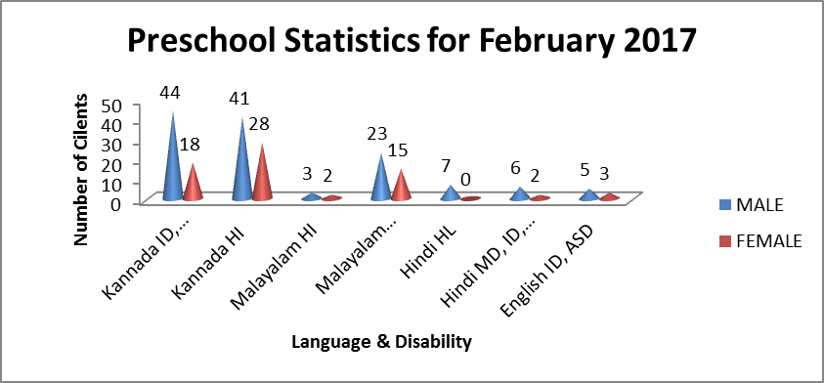

Curricular Support Services – Supportive training to augment education in mainstream school/ other educational programmes – Mr.Harish
 | Language | HL | MR/CP/Down’s/LD | PDD | Total No.of clients | No. Of sessions
 | Kannada | 04 | 14 | -- | 18 | 115
 | Malayalam | -- | 02 | -- | 02 | 09
 | Hindi | 02 | 02 | -- | 04 | 19
 | English | 01 | 01 | 01 | 03 | 18
 | Telugu | -- | 01 | -- | 01 | 06
 | Tamil | -- | -- | -- | -- | --
 | Total |  |  |  | 28 | 167
No. of clients promoted to the next higher level of service:
No. discharged :
No. of Old clients :
No. of New clients enrolled:
No. discontinued:

Individualised Educational Programme (IEP) – Training in functional academics for out of school individuals– Mr. Harish
 | Language | HL | MR/CP/Down’s/LD | PDD | Total No.of clients | No. Of sessions
 | Kannada | 01 | 04 | -- | 05 | 33
 | Malayalam | 01 | 02 | -- | 03 | 07
 | Hindi | -- | -- | -- | -- | --
 | English | -- | -- | 01 | 01 | 2
 | Telugu | -- | -- | -- | -- | --
 | Tamil | -- | -- | -- | -- | --
 | Total |  |  |  | 09 | 42

Demonstration Training – Short-term demonstration to caregivers in any of the above –
Mr. Harish
Language | HL | MR/CP/Down’s/LD | PDD | Total No.of clients | No. Of sessions
Kannada | -- | -- | -- | -- | --
Malayalam | -- | 01 | -- | 01 | 05
Hindi | -- | -- | -- | -- | --
English | -- | -- | -- | -- | --
Telugu | -- | -- | -- | -- | --
Tamil | -- | -- | -- | -- | --
Total |  |  |  | 01 | 05

Preschool Parent Empowerment Programme – PPEP (Mr. Murshidul Alam):
Buffer programme for children awaiting for preschool admission | Language | HL | ID | CP | ASD | MD | LD | DD | Total No. of clients | No. Of sessions
 | Kannada | 30 | 15 | 00 | 01 | 06 | -- | -- | 52 | 76
 | Malayalam | 00 | 15 | 01 | 07 | 03 | -- | -- | 26 | 23
 | Hindi | 05 | 01 | -- | -- | -- | -- | -- | 06 | 38
 | English | 00 | 00 | -- | -- | -- | -- | -- | 00 | 00
 | Telugu | 07 | -- | -- | -- | -- | -- | -- | 07 | 18
 | Tamil | 06 | -- | -- | -- | -- | -- | -- | 06 | 18
Total |  |  |  |  |  |  |  |  | 97 | 173
No. of clients promoted to the next higher level of service: 00
No. discharged : Nil
No. of Old clients :
No. of New clients enrolled:
No. discontinued: 05 (Malayalam: MD= 01 (Fe), HL= 2(1=M, 1=Fe), Hindi: 1 ( Fe), Telugu= 01 (Fe) )

Parent-Infant Programme – PIP (Ms. Leelarani) . (Birth to 2 ½ years)
Early stimulation programme for infants & toddlers with communication disorders | Language | HL | ID | CP | ASD | MD | LD | DD | Total No. of clients | Total No. Of sessions
 | Kannada | 4 | 1 | - | 1 | 5 | - | - | 11 | 54
 | Malayalam | 01 | 01 | - | - | 06 | - | 6 | 14 | 64
 | Hindi | 04 | - | - | - | 01 | - | - | 05 | 20
 | English | - | 01 | - | - | 0 | - | - | 01 | 8
 | Telugu | - | - | - | - | - | - | - | 0 | 0
 | Tamil | - | - | - | - | - | - | - | 0 | 0
 | Total |  |  |  |  |  |  |  | 31 | 146
Specific age range:
No. of Old clients :28
No. of New clients enrolled: 03
No. discharged : NIL
No. discontinued:03
No. of Promoted to next level: 02

Library of Books & Toys – LiBoToy  (Ms. P. V. Ramanakumari & Ms. P. V. Manjula): Services issuing educational toys & books for home-based training | Total number of members enrolled - 130  No. of new members: - 8  Amount – 400/-  Total number of sessions –24
 | Age group | Total number
 | 0-2.6 yrs | 11
 | 2.6-4 yrs | 10
 | 4.0-6yrs | 98
 | 6 yrs and above | 11

Services | Number of Clients | Number of Sessions
Guidance & Counselling | 26 | 25
Co-Curricular Training | 197(includes GEGCS) | 48
U-SAFE | 49 | 22

Supports for Empowering Caregivers
Name of Training Unit | No. of Parent  Beneficiaries | No. of Sessions | Content of Training
Caregiver Computer Training Unit | -- | -- | --
Caregiver Literacy Training Unit | 8 | 12 | Meaningful reading and writing.

Sd/-
Prof. M. Pushpavathi
HOD – Special Education

